Jahia Book
Development
Chapter 4 - Development

Jahia
9 route des Jeunes, CH-1227, Carouge Switzerland
http://www.jahia.com > The company web site http://www.jahia.net > The community web site

Version
This table records the versions of this document and their last updates
Version | Author | Date | Modifications
1.0 | Jonathan Coates | 2008-03-19 | Initial document
1.1 | Stéphanie Rouaud | 2008-07-11 | Add missing chapter and cutting in small chapter

Summary
Page
Version 2
Summary 3
Working with Jahia 4
Working with Eclipse 5
Introduction 5
Requirements 5
Setup procedure 5
Working with IDEs 16
Advanced Templates 17
AJAX 18
What it’s good for 18
Javascript size 18
DOM manipulation implementation problems (memory leaks) 18
Portlets 19
Design 19
Deployment 19
Performance impact 19
Portlets fine-tuning 20
During development 20
In production 20
Integrating external content 21
Portlets 21
Webclipping 21
WebClipBuilder 21
IFrame 21
Javascript resizing 21
RSS Feeds 21
Performance issues 21
Caching 21
Integrating custom authentification 21
WebDAV configuration 21
Customizing error pages 22
URL Rewriting 23
Using Apache Web Server 23
Rewriting URLs without Apache Web Server 23
Development 26
Best practices 26

Working with Jahia

Working with Eclipse

Introduction
This procedure defines the steps that must be followed to install a development environment using the Eclipse IDE. The Eclipse IDE is very interesting because it is now a very strong solution for Java developers, and is at the same time entirely free. As Jahia is also free for development purposes, this allows you to have a 100% free CMS and portal development environment.
Please note that at the time of writing, these steps were all valid, but of course as software may evolve these might not be as accurate.

Requirements
- Eclipse 3.2.2 or more recent
http://www.eclipse.org/
- Maven 1.0.2 with any JDK or Maven 1.1 with JDK 5 only (won’t work with JDK 6 !). Maven 2 is not supported at the moment.
http://maven.apache.org/maven-1.x/
- Subversive SVN client for Eclipse 1.1.3 or more recent.
http://www.polarion.org/index.php?page=overview&project=subversive
- JDK 1.4 or more recent (see Maven requirements for limitations with JDK 6)
http://java.sun.com/javase/downloads/index_jdk5.jsp

Setup procedure
- Install Eclipse 3.2.2 or more recent
- Modify the eclipse.ini file to change the default –Xmx256M to a higher value (such as –Xmx512M or –Xmx768M). Under Mac OS X this file will be found by right-clicking on Eclipse, then “Show package Contents” -> Contents -> Mac OS -> eclipse.ini
- Install Subversive SVN client for Eclipse, which seems more stable than Subclipse.
http://www.polarion.org/index.php?page=download&project=subversive
You can find the installation instructions for Subversive here : http://www.polarion.org/projects/subversive/download/Installation_Instructions.pdf
- Once all is configured, start Eclipse and go into the SVN Repository Exploring view (can be done by opening in the Window menu the “Open perspective option)
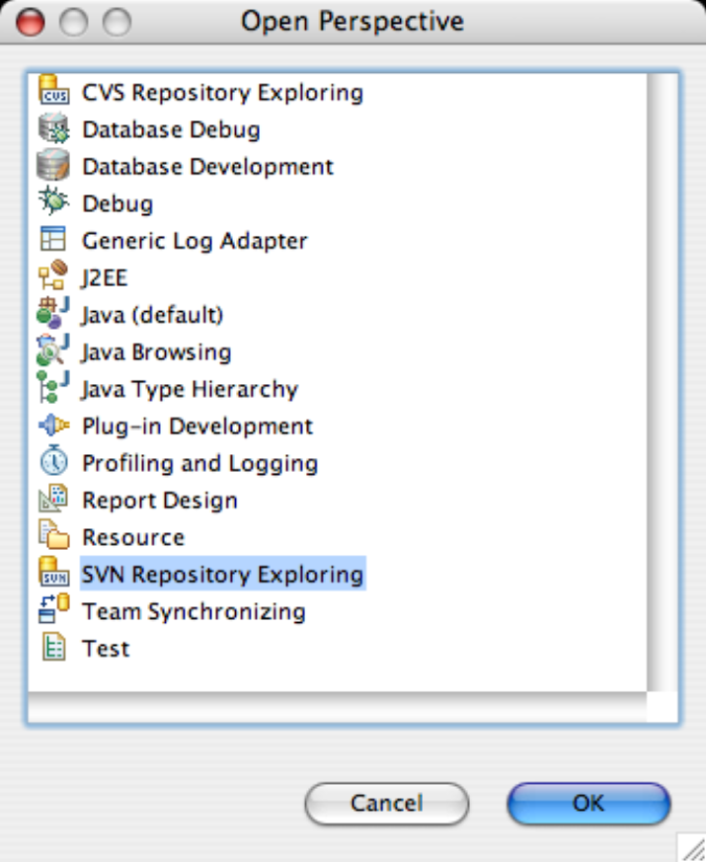
- Click on the “Add repository” button in the upper right corner of the repository view window :

- In the window, enter the following URL :
https://svndev.jahia.net/svn/common-jahiaprojects/
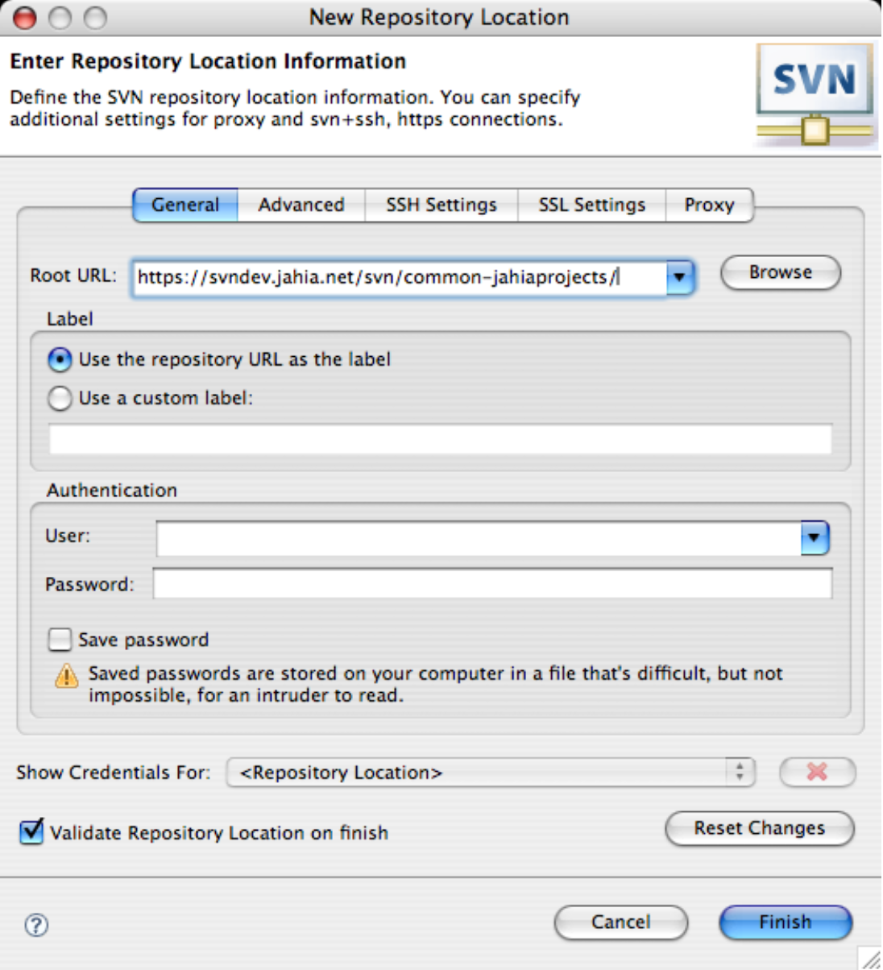
If you get a message asking to confirm the certificate, click on “Trust always”.
- Also add the following repository
https://svndev.jahia.net/svn/common-packagedwebapps/ as well as https://svndev.jahia.net/svn/maven-jahiawar-plugin/
- Add the Jahia application repository : https://svndev.jahia.net/svn/jahia/
- Open each repository and right-click the “trunk” and select “Find/ Check out As …”
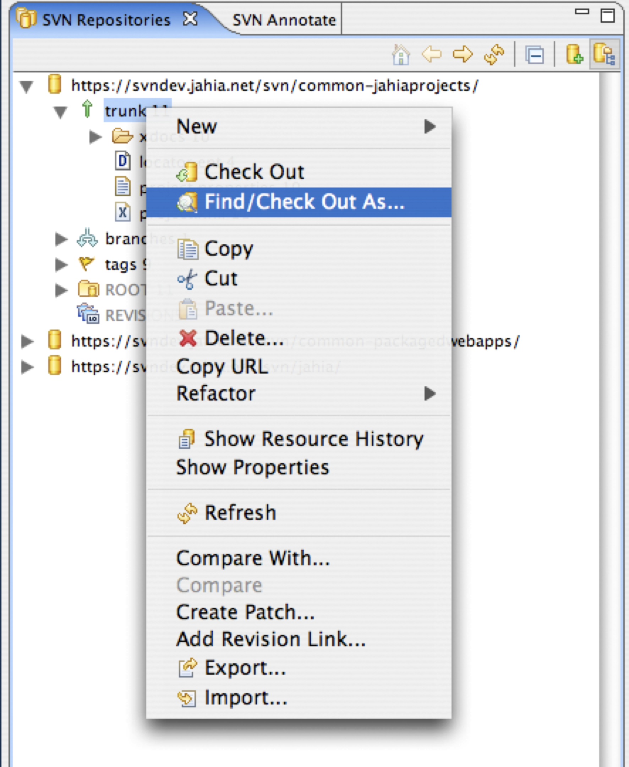
Select “Check out as a project with the name specified” and retype the name of the project (trunk is the default input but we need to change this). So for example for the URL https://svndev.jahia.net/svn/common-jahiaprojects/trunk, the project name will be “common-jahiaprojects”. Make sure you type these correctly as it is important !
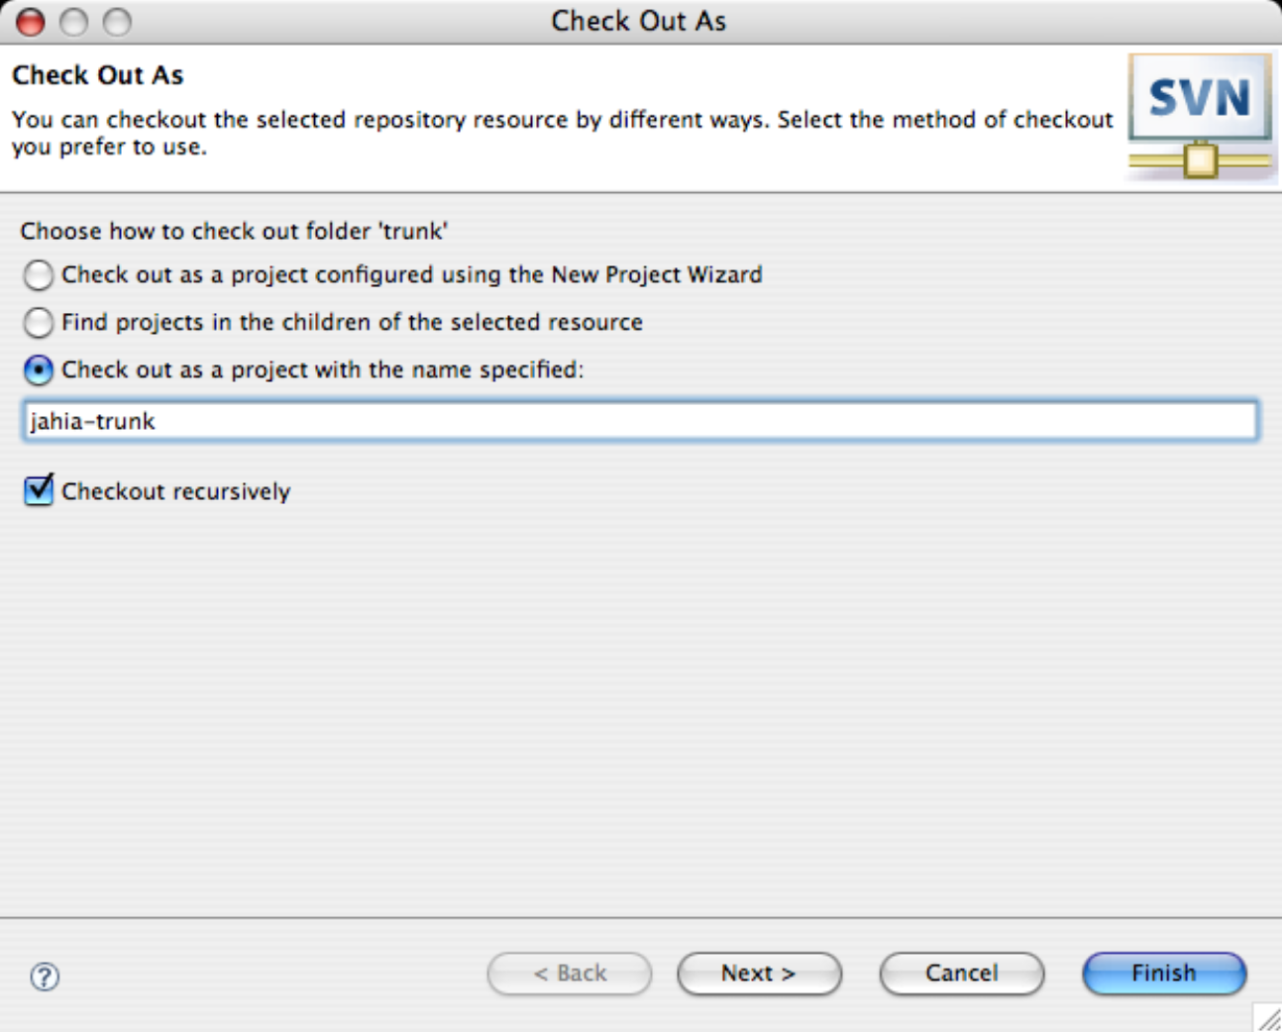
If you would have wanted to checkout a branch instead of the trunk, you should first open the branch you want to checkout, and then right-click and select “Find/Check out As…” and follow the same process.
You can find more information about the branches here : http://svn.jahia.org/svn/jahia/branches/
- Click “Next”
- You can leave the default workspace location for checkout, it should do fine :
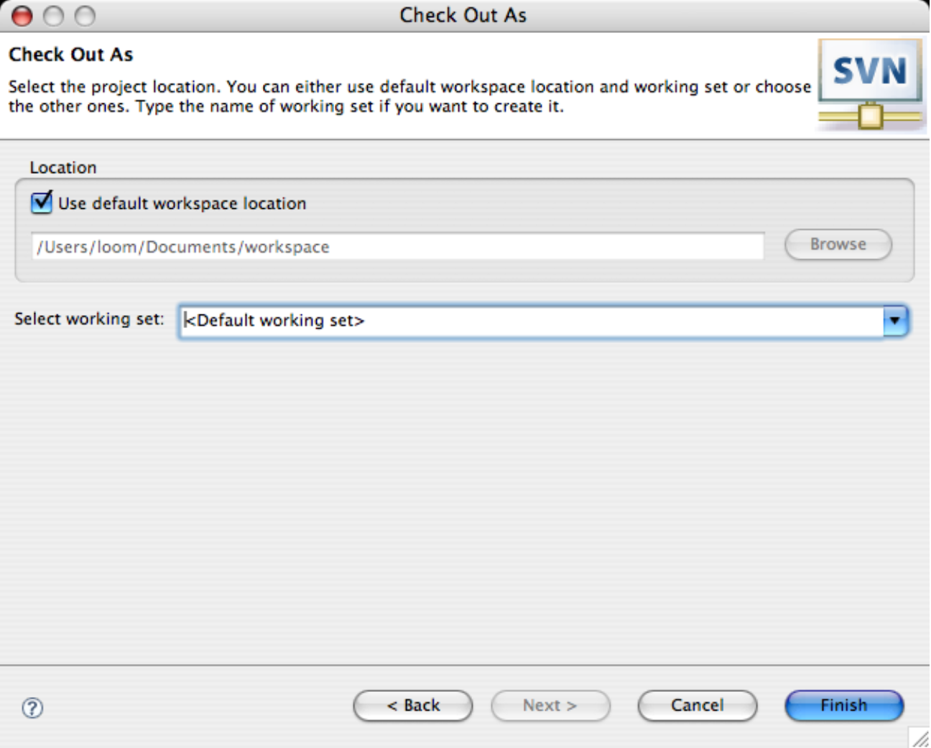
- Click “Finish”, which should start the checkout of the project.
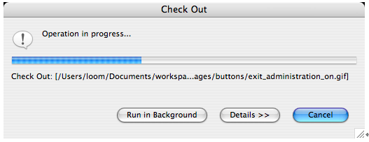
- Repeat steps 9 through 12 for the repositories : “common-packagedwebapps”, “maven-jahiawar-plugin” and the “jahia” branch you want.
- Open a command line, and go to your workspace directory. You should have the following content in this directory :
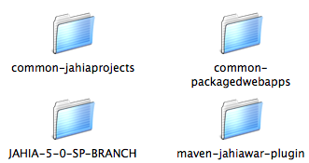
- Change into the maven-jahiawar-plugin and launch : maven plugin:install
- Define a catalina.home.dir property in your ${user.home}/build.properties that points to your Tomcat installation (only Tomcat 5 supported for the moment). You will also have to set a catalina.version.major variable (for Tomcat 5.5 the version should be “5.5”, for 6 it should be “6”, 5.5 is an exception). It should look like this :
catalina.home.dir=/Users/loom/java/technologies/jakarta-tomcat-5.5.9
catalina.version.major=5.5
- Download and uncompress XDoclet version 1.2.3 from http://xdoclet.sourceforge.net/xdoclet/index.html.
- You must then install the XDoclet Maven plugin, This plug-in is located in the same folder as the other xdoclet jar files, and is named maven-xdoclet-plugin-&lt;version&gt;.jar. Just drop it in your $MAVEN_HOME/plugins directory and you're ready to go. You might have to delete your $MAVEN_HOME/cache/*.* files and previous un-zipped XDoclet plug-ins in $MAVEN_HOME/plugins to be able to get it to work properly.
- In the “JAHIA-5-0-SP-BRANCH” directory (or whatever directory you have checkouted from the Jahia SVN, change into the core directory and type the following command : “maven”
This should trigger the building of the project with Maven. If you see errors, make sure all the 3 projects were extracted at the same level. If all goes well you should see a “BUILD SUCCESSFUL” message.
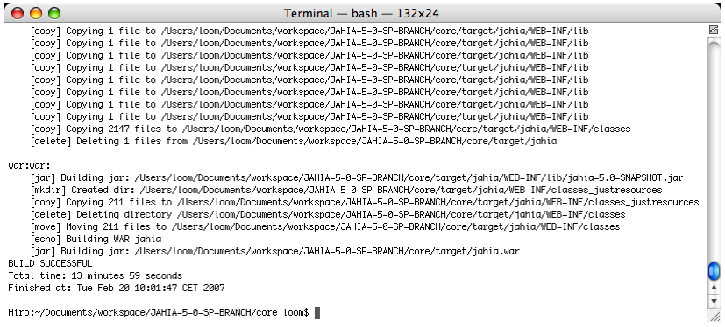
- Still in the command line in the “core” directory, type : “maven –o eclipse” to generate the Eclipse project file using Maven.
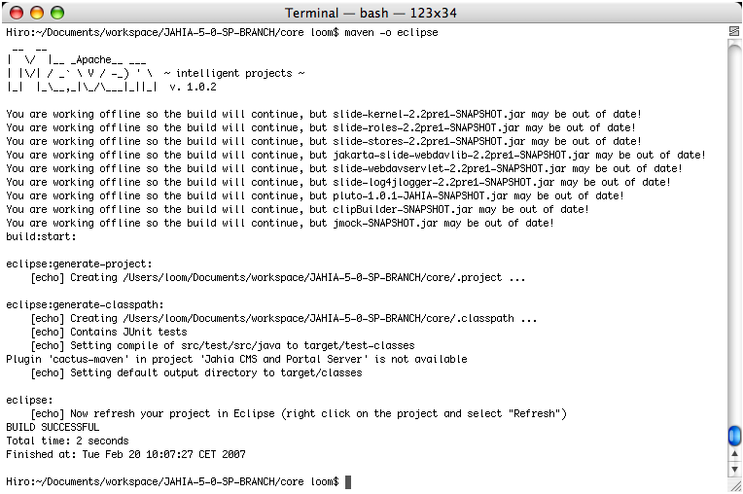
- (Optional) If you intend to work simultaneously with multiple branches of Jahia, you will have to modify the generated project name resulting of the “maven eclipse” command. This is necessary because Eclipse doesn’t support importing two projects with the same name. In order to change the project name, you will have to modify with a text editor the following file : jahia/core/.project and modify the following lines :
<projectDescription>
<name>jahia</name>
to something like :
<projectDescription>
<name>jahia-trunk-core</name>
- Projects generated by Maven use a variable called MAVEN_REPO in Eclipse projects, that points to your local copy of the Maven repository. We now need to set this variable’s value. First open the Eclipse preferences screen :
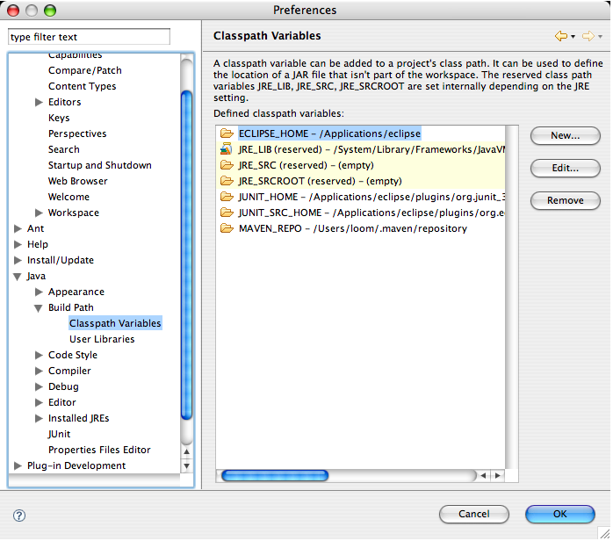
- Then click “New..” and add the Maven repository location as illustrated below :
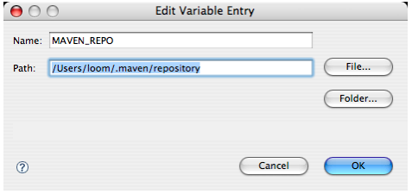
- In the “File” menu, select “Import”.
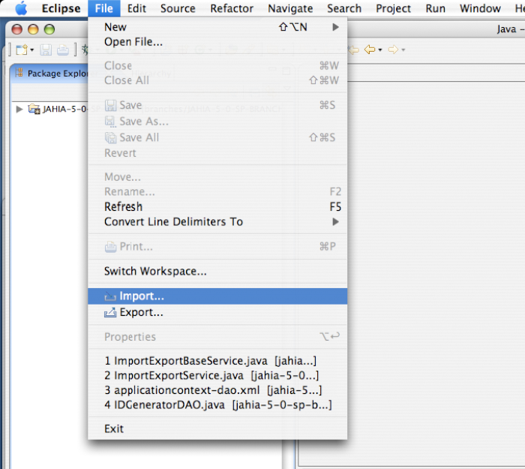
- Select “General” -> “Existing Projects into workspace”
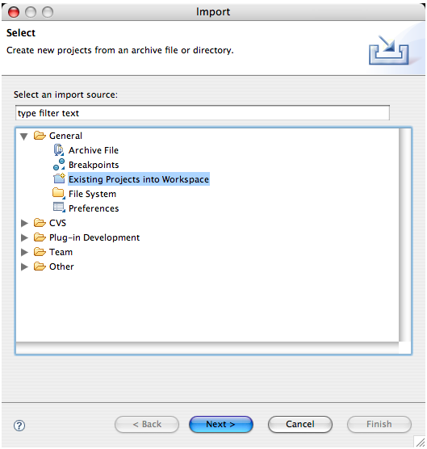
- Select the “core” directory under the Jahia main directory.
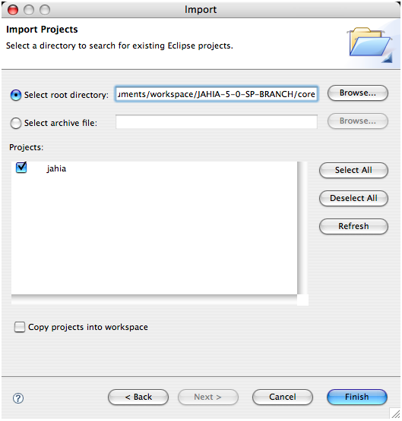
- Click “Finish”. You should now have two Jahia entries in your “Package Explorer” view. This is normal, once of them represents the checked-out structure, while the other is the actual Java project that will be used to compile Jahia from Eclipse.
- At this point Eclipse will rebuild the workspace, which might take some time. It is due to the SVN plugin connecting to the repository to retrieve information for all the files, and there are a lot of these. You might see messages such as “Updating SVN Cache” or “Generating workspace” on the bottom status bar of Eclipse. These are normal and should complete at least once.
- Once these steps are completed, you are now ready to work with Eclipse. If you want to deploy Jahia, go back to a command line and go into the jahia/core directory and type : “maven deploy:tomcat”. Other interesting maven goals include :
- xdoclet:hibernatedoclet will regenerate all the Hibernate mapping files. In order for this goal to function properly, make sure you have properly installed the XDoclet Maven plugin in step 18.
- undeploy:tomcat will undeploy all of Jahia’s files from your Tomcat install
- reset:tomcat will reset the Jahia deployment in Tomcat so that you can reconfigure Jahia (will launch the configuration wizard all over again)
- hotdeploy:tomcat will deploy all the updated classes/JSP, etc, WITHOUT touching the configuration in Jahia. This is the goal you will use most often when developing with Jahia, to deploy just what you modified. Please note that the name may be confusing to JEE administrators : this goal does NOT perform a undeploy/deploy cycle on the application server and assumes that you have stopped your application server before executing it.
All deployment goals should only be executed when the application server is stopped !

Working with IDEs

Advanced Templates

AJAX

What it’s good for

Javascript size

DOM manipulation implementation problems (memory leaks)

Portlets

Design

Deployment

Performance impact

Portlets fine-tuning

During development
- Render must be really fast
When developing portlets, focus all your efforts on making sure that whatever your portlets render will be really fast, as this is where your application will be most stressed, as each time a page is requested, potentially the render (or do* methods) will be called.
So for example if your portlets are accessing remote data (database or other external systems), you might want to consider caching the default views to offer better performance to the end-user. Also using systems such as Hibernate or EJBs that offer built-in caching can be a good idea.
- Use renderURLs instead of actionURL
Similar to optimizing rendering, try to avoid as much processAction calls as possible, especially if no data is being processed, only a default view is refreshed.
- External portlet performance guide
You can find more information about portlet performance tuning here : http://edocs.bea.com/wlp/docs92/portlets/performance.html
It should be noted that some of these points are specific to the application server and not available on Jahia.

In production
- Limit the number of deployed portlets
As each portlet is actually contained in a full-fledged JEE application, it is a good idea to limit to a minimum the number of deployed portlets, as they each consume memory not only for their logic operations, but also for all the classes loaded in memory. Also large application will consume more memory just for their codebase, so plan your memory sizing accordingly.

Integrating external content

Portlets

Webclipping

WebClipBuilder

IFrame

Javascript resizing

RSS Feeds

Performance issues

Caching
Avoid deactivating caching
Avoid using two page fields in the same container

Integrating custom authentification
TODO : include external document

WebDAV configuration
Deactivating directory browsing :
In the web.xml file, find on the WebDAV servlet the parameter :
<init-param>
<param-name>directory-browsing</param-name>
<param-value>true</param-value>
</init-param>
And set it to “false”.

Customizing error pages
TODO : describe how to

URL Rewriting

Using Apache Web Server

Rewriting URLs without Apache Web Server
As an alternative to performing URL rewriting using the Apache Web Server with the mod_rewrite and mod_proxy plugins, we present here a method using a J2EE-compatible web filter, that we will integrate with Jahia.
This filter, called the Url Rewrite Filter, is available on the following web site : http://tuckey.org/urlrewrite/ . We have tested version Beta 3.0.4 with Jahia 5.0SP3 and it seems to work well. Installation is pretty straight-forward, simply :
- Extract the ZIP file to a temporary directory.
- Copy the WEB-INF/urlrewrite.xml file to Jahia’s tomcat/webapps/jahia/WEB-INF directory
- Copy the WEB-INF/lib/urlrewrite-VERSION.jar to Jahia’s tomcat/webapps/jahia/WEB-INF/lib directory
- Add the following lines to Jahia’s tomcat/webapps/jahia/WEB-INF/web.xml file :
Just before :
<filter-mapping>
<filter-name>Set Header Filter</filter-name>
<url-pattern>/jsp/jahia/*</url-pattern>
</filter-mapping>
Add :
<filter>
<filter-name>UrlRewriteFilter</filter-name>
<filter-class>org.tuckey.web.filters.urlrewrite.UrlRewriteFilter</filter-class>
<!-- set the amount of seconds the conf file will be checked for reload
can be a valid integer (0 denotes check every time,
-1 denotes no reload check, default -1) -->
<init-param>
<param-name>confReloadCheckInterval</param-name>
<param-value>20</param-value>
</init-param>
<!-- sets up log level (will be logged to context log)
can be: TRACE, DEBUG, INFO (default), WARN, ERROR, FATAL, log4j, commons,
sysout:{level} (ie, sysout:DEBUG)
if you are having trouble using normal levels use sysout:DEBUG
(default WARN) -->
<init-param>
<param-name>logLevel</param-name>
<param-value>DEBUG</param-value>
</init-param>
</filter>
Just before :
<!-- Display request URLs - Pattern-->
<filter-mapping>
<filter-name>ESIHeaderFilter</filter-name>
<url-pattern>/*</url-pattern>
</filter-mapping>
Add :
<filter-mapping>
<filter-name>UrlRewriteFilter</filter-name>
<url-pattern>/*</url-pattern>
</filter-mapping>
- In the tomcat/webapps/jahia/WEB-INF/urlrewrite.xml file, insert the following rules at the end of the file (just before the closing </urlrewrite> tag :
<rule>
<from>/(.*?)(/(.*?))?/page_([0-9]+).html</from>
<to>/Jahia/site/$1/$3/pid/$4</to>
</rule>

<outbound-rule>
<from>/Jahia/(site/(.*?)/)?pid/([0-9]+)</from>
<to>/$2/page_$3.html</to>
</outbound-rule>
The above rule is an example, and is of course limited in functionality. Basically it will rewrite Jahia URLs looking like this :
http://localhost:8080/jahia/Jahia/site/mySite/pid/10
to something like :
http://localhost:8080/jahia/mySite/page_10.html
This rule isn’t fully integrated with Jahia, because it doesn’t support EDIT mode or cache control parameters, and isn’t fully tested with page URL keys. But it serves mostly as an illustration of what is possibly with this technology, and it is relatively easy to expand on this example to configure more advanced rules. The Url Rewrite Filter is a powerful little tool that can do everything the mod_rewrite Apache plugin can do and a lot more ! And the nice thing is that it is Servlet API 2.3 compliant and that it can therefore be installed on any web application server such as Tomcat, Orion, Resin, WebLogic, Websphere; provided of course the web application server is recent enough to support this version of the Servlet API.
It should be noted also that Jahia installations that use the ESI cache server will have to move the Url Rewrite filter to the ESI cache server Tomcat installation, rather than installing it directly in Jahia. This works exactly the same way as we have described here, except that the configuration will have to happen in the ESI’s web application context instead of Jahia’s (specifically in the tomcat/ROOT directory by default).
As the Url Rewrite Filter supports regular expressions, another useful tool to develop and test rules is an application such as RegexBuddy (for Windows), that lets you develop and test regular expressions. You can find this tool here : http://www.regexbuddy.com/
You might ask why we should configure URL rewriting at the application server level rather than using an Apache front-end web server? Apart from the added flexibility (the filter even supports custom rules implemented in Java), using an Apache front-end server adds an extra indirection processing, through the mod_jk layer. While this has the advantage of adding load-balancing, it also has the disadvantage of adding an extra communication layer before reaching the Jahia CMS server. Therefore, for installations that are very performance sensitive, but do not require a software load-balancer (because for example they use a hardware balancer such as an F5, http://www.f5.com/ ), using this filter still provides the URL rewriting possibility.

Development

Best practices
Describe here the best practices for development on Jahia systems. Using a Subversion repository, Maven 2, etc…

